Willrich Precision: Ph 866-945-5742
sales@willrich.com
Product Name/Title:
Sylvac Digital Probes

Pictures:
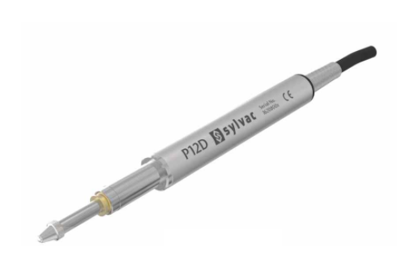
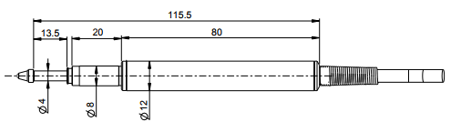

Icons:

Descriptions:
- Absolute digital measuring probes feature a travel range of 0.5” / 12.7mm, and use a patented dual inductive and capacitive system.
- Probes contain an integrated correction, and do not require pairing with a display unit, while also being able to output data directly onto a PC by USB.
- Probes come with an interchangeable stainless steel contact point, with a 0.078” / 2mm diameter tungsten carbide ball point, and a M2.5 thread.
- Each probe includes a calibration certificate.
- Probes have an IP rating of 54.
- Standard cable length 5.9’ / 1.8m

Part numbers/etc:
Part Number | Measuring Force | Repeatability | Maximum Error | Resolution | Output Type
54-619-101-2 | 0.2-0.3N | 0.000003”/0.08μm | 0.00002”/0.6μm | 0.0000004”/0.01μm | USB
54-619-101-8 | 0.6N | 0.000003”/0.08μm | 0.00002”/0.6μm | 0.0000004”/0.01μm | USB
54-619-121-2 | 0.2-0.3N | 0.000003”/0.08μm | 0.00002”/0.6μm | 0.0000004”/0.01μm | M8
54-619-121-8 | 0.6N | 0.000003”/0.08μm | 0.00002”/0.6μm | 0.0000004”/0.01μm | M8
54-619-201-2 | 0.4-0.8N | 0.00001”/0.2μm | 0.00004”/1μm | 0.000004”/0.1μm | USB
54-619-101-7 | 0.2-0.3N | 0.00001”/0.2μm | 0.00004”/1μm | 0.000004”/0.1μm | USB

