Willrich Precision Ph 866-945-5742 / sales@willrich.com

EXTERNAL THREAD INSPECTION
PITCH (MINIMUM MATERIAL) DIAMETER
Inserts "A" and "J" both contain balls of Best Wire size, and give a reading which excludes lead error but not angular errors. The PD inserts can be used for both left hand and right hand threads.
TAPER AND OVALITY
Use inserts "A" and "J" at intervals along the thread for taper, and around the thread for ovality.
INCLUDED ANGLE
Use inserts "D" and "J". The ball in "D" is smaller than that in Pitch Diameter insert "A", and should seat a prescribed distance deeper. If it does not, angular error is present. The degree of error and its effect on PD can be determined by using a formula.
UNEQUAL HALF-ANGLES
Opposite insert "J", use "E"; then either "F" or "G". "E" has full flanks, while "F" and "G" are limited to 0.1H contact. Where half-angles are unequal the thread groove will be tilted, and "E" will seat more shallow because its broader contact surfaces will meet greater interference from the tilted groove. The degree of tilt and its effect on PD. is available through thread spec. publications.
MINOR DIAMETER
Use inserts "B" and "J".
MAJOR DIAMETER
Concentricity between major and PD is checked by using inserts "C" and "J". Major Diameter size, roundness and taper are checked by a pair of "C" inserts.
FUNCTIONAL (MAXIMUM) MATERIAL DIAMETER
Paired inserts (C) (functional) are Helically Manufactured for a single PD/Pitch/Lead combination. A separate pair is required for each combination.

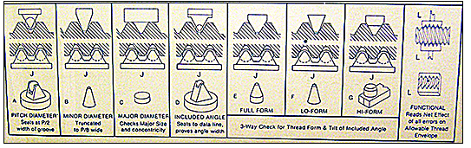
SIMPLE SETTING METHOD (60 degree threads)
The PD inserts are set "between the balls". The Pitch Diameter setting equals the low, nominal, or high PD minus the ball radius. The Functional Inserts are set with a supplied master.
All contacts (except Major Diameter) that are used opposite contact J are marked with a constant dimension thus: CD +.0214; or CD -.0261. Setting size is equal to the PD setting plus or minus the constant dimension.
Paired Major Diameter inserts are set exactly to Major Diameter size. When a single Major Diameter insert is used opposite a J insert to check concentricity, no precise setting is required. The inserts are brought into contact with the workpiece and the indicator is read for runout.

