Internal Gages
Willrich Precision : 866-945-5742/sales@willrich.com

INTERNAL GAGE FRAMES
The basic internal gage frames are available in two models. The G-600 with a capacity from .190 inches to 4.5 inches basic and the G-1200 with a capacity from 6 inches to 18 inches. The gage frames are extremely accurate, .000050 inch repeatability is guaranteed. The system was designed to take the abuse of shop use although it is precise enough for the requirements of the quality control or metrology laboratory. Two extension kits are available. The G-600X increases the capacity of the G-600 frame to 5.5 inches basic and the G-1200X increases the capacity of the G-1200 frame to 24 inches basic. The gaging pressure of both internal frames can be adjusted by the operator thereby allowing very "thin wall" parts to be measured, minimizing destortion !
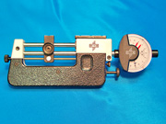 | 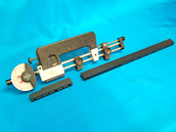

INTERNAL GAGE FINGERS
MTG offers more sizes, types, and reaches of internal fingers than any other gage manufacturer. Fingers can be manufactured to measure most thread forms including Unified, Buttress, Acme, Stub Acme, Metric, Whitworth, Lowenherz, Ball, 40 Degree Worm, Aero, and Square. Additional geometries are available for bearing races, grooves, bores, tapered bores, gears, splines, and dovetails. Six different lengths are available.
FINGER PREFIX OAL LENGTH OF FINGER MINIMUM / MAXIMUM DIAMETER
1.5U | ................. | Basic Length 1.25 Inches | .......... | Under 5/8 In. Diameter
1.5 | ................. | Basic Length 1.5 lnches | .......... | 5/8 In. Diameter & Over
2.25 | ................. | Basic Length 2.25 Inches | .......... | 3/4 In. Diameter & Over
3.0 | ................. | Basic Length 3.25 Inches | .......... | 1.0 In. Diameter & Over
4.0 | ................. | Basic Length 4.12 Inches | .......... | 1.0 In. Diameter & Over
5.0 | ................. | Basic Length 5.0 Inches | .......... | l.5 In. Diameter & Over

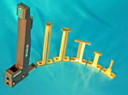 | 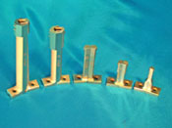 | 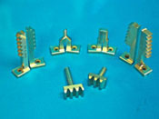

INTERNAL GAGE STANDS
MTG offers simplicity in measurement. Many times it is necessary for the user to measure more than one element of a thread. Shown below (pictured in red) is an Internal System for thread measurement. The first gage is set up to measure the pitch diameter, the second gage measures the diametrical equivalent of the form (single thread), and the third measures functional diameter. The gage stand shown (three risers) is a GS-3. Two risers is a GS-2. One riser is a GS-1. The GS-1 is expandable to either a GS-2 or GS-3 simply by purchasing additional risers because all three risers share a common base. A round base (GS-O) stand is used to hold the gage frame when measuring grooves and bores of a light weight part with a squaring plate installed. (SEE INTERNAL BORES AND GROOVES BELOW)

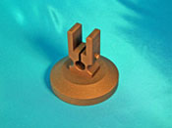 | 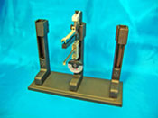 | 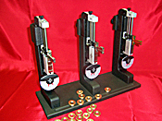
GS-0 | GS-3 | GS-3

