Willrich Precision Ph 866-945-5742 email: sales@willrich.com

INTERNAL THREAD INSPECTION
Thread plug gages can neither isolate compound errors in female threads nor reveal the amount of error. They merely suggest that "something is wrong." Now the ''MTG System'' lets the producer of internal threads make his own step-by-step analysis with a hand-held gage in a few minutes. Required data is obtained by use of interchangeable fingers shown on the chart below. Most significant of the fingers is ''J'', which contains two floating balls of "Best Wire Size''. These balls make contact at the P/2 width, or pitch circle of the thread grooves. Because they float, the balls will seat at the pitch circle whether the lead is short, long, correct or drunken. Finger "J" is used in conjunction with every upper finger in the thread series except the "Functional", and provides an identical base line in every case!

MTG ZONAL METHOD
PITCH (MINIMUM MATERIAL) DIAMETER
Fingers "A" and "J" both have tungsten carbide balls of "Best Wire Size", and give a reading which excludes lead error but not angular errors. PD fingers can be used for right or left hand threads.
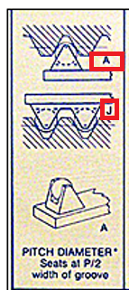

TAPER AND OVALITY
Use fingers "A" and "J" at intervals along thread for taper and around the thread for ovality.
INCLUDED ANGLE
Use fingers "D" and "J". The ball in "D" is smaller than in pitch diameter finger "A", and should seat a prescribed distance deeper. If it does not, angular error is present. The degree of error and its effect on P.D. can be determined by a formula.
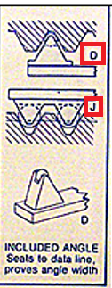
MAJOR DIAMETER
Use fingers "B" and "J"
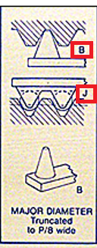

UNEQUAL HALF ANGLES
Opposite finger "J", use "E"; then either "F" or "G". "E" has full flanks, while "F" and "G" are limited to 0.1H contact. Where half-angles are unequal, the thread groove will be tilted, and ''E'' will seat more shallow because its broader contact surfaces will meet greater interference from the tilted groove. The degree of tilt and its effect on PD is available through thread specification publications.
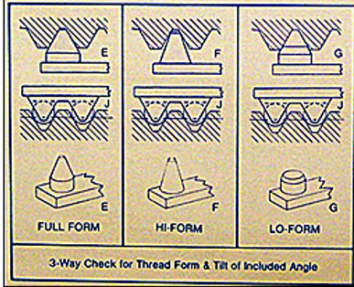

MINOR DIAMETER
Concentricity between minor and PD is measured by using fingers "C" and "J" . Minor diameter size, roundness and taper are checked with a pair of "C" fingers.
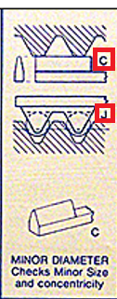

FUNCTIONAL (MAXIMUM MATERIAL) DIAMETER
Paired fingers "L" are helically ground for a single PD, pitch/lead combination which will measure the net effect of all errors.
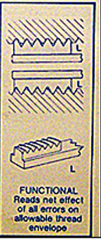
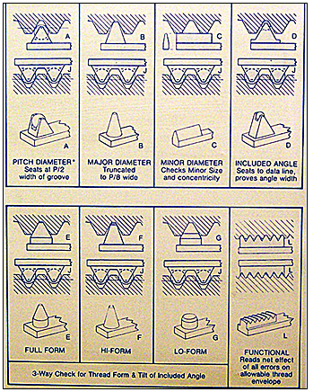

SIMPLE SETTING METHOD (60 degree threads)
The MTG gage is set "over the balls" or "over the crests" with gage blocks, micrometers, super micrometers, or plain cylindrical ring gages. No threaded masters are needed.
The pitch diameter setting equals the pitch diameter (low, nominal or high) plus the ball radius. The ball diameter is etched on the pitch diameter fingers. All contacts (except minor diameter) that are used opposite contact "J" are marked with a constant dimension thus: CD +.0214 or CD -.0261. Setting size is equal to the PD. setting plus or minus the constant dimension.
Functional fingers are marked with a specific setting size thus; OD .7501.
Paired minor diameter fingers are set exactly to the minor diameter size. When a single minor diameter finger is used opposite a ''J'' finger to check concentricity, no precise setting is required.

