Stereo zoom Microscope Accessories
A wide range of accessories are available to complement the SX Elite family of products.

Image Capture, Archive & Documentation
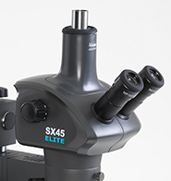 | - Trinocular head option permits the use of digital or video camera.  (Only available on the SX45-TR Elite model)  - Modular multimedia solutions are available for image archiving,  acquisition, processing, analysis and documentation.

LED Ring light
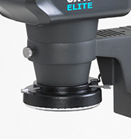 | - For use with bench stand variant, where additional surface  illumination is required (standard option with articulated arm and  boom mount variants).

Floating stage
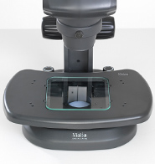 | - For use with bench stand models, the floating stage provides smooth  sample control, ideal for inspection tasks.

Polarisation Set
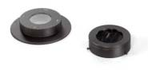 | - Useful accessory when used for material science,  metallurgy, petrology, as well as many geological and pharmaceutical applications.  - Polarising filters can be accommodated with bench  stand variant.

