There are a number of ways to measure the flatness of a surface. The most common method within the Flat Lapping sector is by using a Monochromatic Sodium light unit and an Optical Flat. This gives extremely precise measurements, more accurate than most CMM measurements, in an economical way.

When you call out parallelism, flatness is implied (you are measuring a surface variation between two parallel planes = flatness) However the biggest difference is parallelism is measured with respect to a datum, ensuring both the datum and reference feature are always parallel

Flatness – The condition of a surface having all elements in one plane. Parallelism– The condition of a surface, line, or axis which is equidistant at all from a datum plane or axis. It's not rocket science. ... Flatness is a feature compared to itself, while parallelism requires that a feature be compared to a datum. Think of a table with two missing legs at an angle to the floor. The table top may be within flatness tolerance but would not be parallel to the floor.

How to measure parallelism: Check the parallelism by the indicator, base of which moves on the surface plate. Then check the parallelism of the pink plane to the orange one through its parallelism to the surface plate.
How To measure flatness: The best way to get a reliable measurement reading is to have the probe underneath the part. Example: a LVDT Probe coming up thru a hole in the surface place . Then turn the part to opposite side so the surface to be measured is not effected by the opposite side of the part.

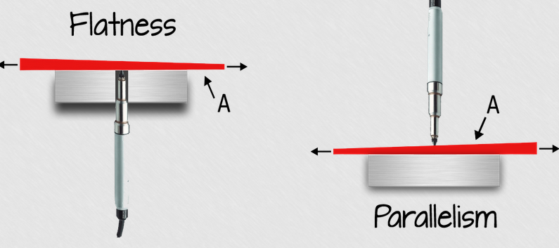

Measuring flatness with a height gage: To use the height gage correctly, the part to be measured is first placed upon 3 columns with adjustable heights. Then, the height gage is run across the surface while looking at the amplitude of the needle. The metrologist adjusts the three columns to minimize the amplitude of the needle. They are adjusting the orientation of the plane to come up with the smallest theoretical sandwich. As you can imagine, this method requires much patience and training. The more common method of using a height gage to evaluate flatness involves placing the part directly on the table (Figure 3). Without the ability to adjust the orientation of the part to minimize the amplitude of the needle, however, you are essentially evaluating parallelism based off of the table, which is sub-optimal. While it is much faster than using the 3-column method, it is important to be aware that using this method can yield false negatives; parts that pass this evaluation are always correct, but parts that fail will need to be evaluated in a different way to ensure that good parts are not sent back for expensive re-work
Willrich Precision
Ph 866-945-5742
info@willrich.com

